ΠΡΟΣΘΕΣΗ ΚΑΙ ΑΦΑΙΡΕΣΗ

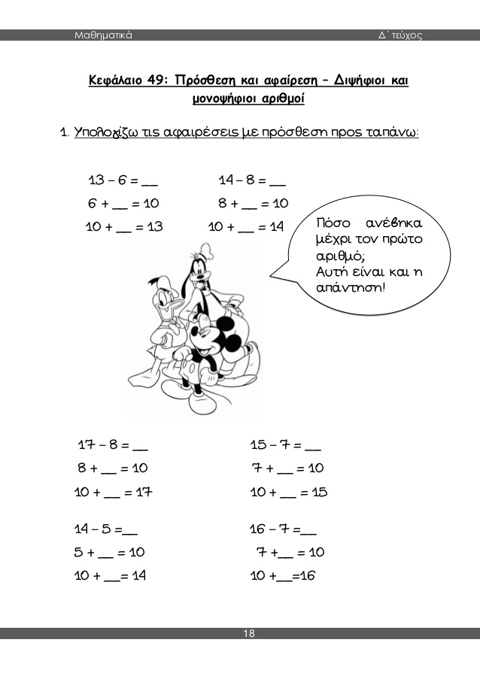ΔΙΨΗΦΙΟΙ ΚΑΙ ΜΟΝΟΨΗΦΙΟΙ ΑΡΙΘΜΟΙ (9-6-20)

13-6=7 14-8= 17-8=

6+4=10 8+__ =10 8+ __ =10

10+3=13 10+ __ =14 10 +__ =17

4+3=7

15-7= 15-7= 14-4=

7+__ =10 7+__ =10 4+__ =10

10+ __ =15 10+ __ =15 10+ __ =14

6+6= 12-9= 8+ __ =10

12-6= 13-7= 6+ __ =10

8+8= 14-9= 7+ __ =10

16-8= 12-8= 17- __ =10

7+7= 18-9= 15- __ =10

14-7= 11-9 13- __ =10

Χρέλια Ανδρεάνα