**Κεφ 45 (26 -5- 20)**

**1)Θυμάμαι την αφαίρεση:**

|  |  |
| --- | --- |
| 10-5= | 9-4= |
| 20-5= | 5-3= |
| 30-5= | 6-2= |
| 40-5= | 8-3= |
| 50-5= | 7-4= |

**2)Υπολογίζω και συμπληρώνω:**

|  |  |  |
| --- | --- | --- |
| 6+6= | 10+5= | 10+7= |
| 7+7= | 15-5= | 17-7= |
| 8+8= | 20+5= | 20+7= |
| 9+9= | 25-5= | 27-7= |
| 10+6= | 10+8= | 10+9= |
| 16-6= | 18-8= | 19-9= |
| 20+6= | 30+8= | 40+9= |
| 26-6= | 38-8= | 49-9= |

9

+1

4

8

+2

9

5

+5

7

**7**

**+3**

**5**

**6**

**+4**

**2**

**3)Βρίσκω το μισό και το διπλάσιο των παρακάτω αριθμών:**

Το μισό:

|  |  |  |  |  |  |  |  |  |
| --- | --- | --- | --- | --- | --- | --- | --- | --- |
| 2 | 4 | 6 | 8 | 10 | 12 | 14 | 16 | 18 |
| 1 | 2 |  |  |  |  |  |  |  |

Το διπλάσιο:

|  |  |  |  |  |  |  |  |  |
| --- | --- | --- | --- | --- | --- | --- | --- | --- |
| 1 | 2 | 3 | 4 | 5 | 6 | 7 | 8 | 9 |
| 2 | 4 |  |  |  |  |  |  |  |

4)Βρίσκω πόσο κάνουν:

8+5= 7+7= 40+7=

13-3= 9+9= 47-7=

10+7= 20+6= 30+9=

17-7= 26-6= 39-9=

10+10= 30+5= 40+8=

20+8= 48-8= 7+6=

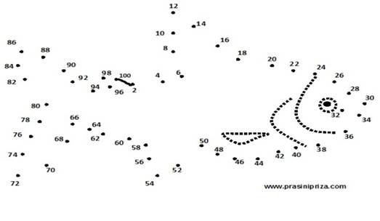

ΧΡΕΛΙΑ ΑΝΔΡΕΑΝΑ