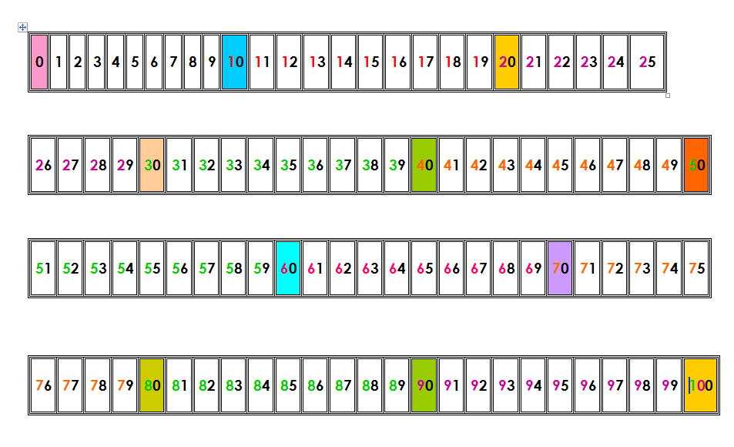ΕΠΑΝΑΛΗΨΗ ΚΕΦ. 45 (27-5-20)

Κάνω τις πράξεις:

9+5= 10+5+3= 12-2= 50-10=

8+3= 10+6+1= 15-3= 40-10=

6+7= 10+1+4= 18-1= 60-10=

4+9= 10+3+4= 19-3= 90-10=

8+6= 10+2+5= 14-4= 80-10=

20-4= 10+2+….=15 100-5= 45-….=40

20-5= 7+3+…..=14 80-5= 85-….=80

20-8= 6+4+…..=13 60-5= 65-….=60

20-6= 5+5+…..=19 40-5= 35-….=30

20-9= 11+3+….=20 30-5= 25-….=20

20-7= 15+2+….=20 90-5= 75-….=70



Συμπληρώνω τους αριθμούς που λείπουν:

|  |  |  |  |  |  |  |  |  |  |  |  |  |  |  |  |
| --- | --- | --- | --- | --- | --- | --- | --- | --- | --- | --- | --- | --- | --- | --- | --- |
| 20 |  |  |  |  |  |  |  |  |  | 30 |  |  |  |  |  |
| 38 |  | 40 |  |  |  |  |  |  |  |  |  |  |  |  | 53 |

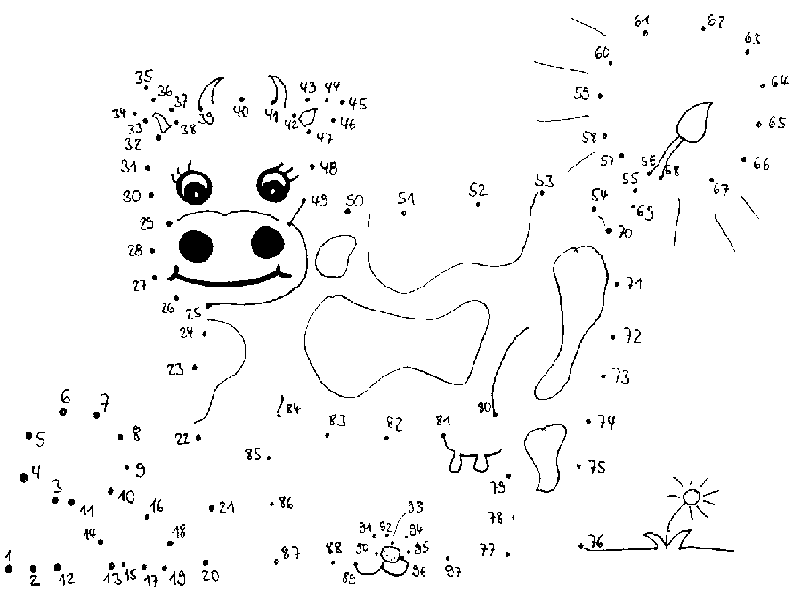

ΧΡΕΛΙΑ ΑΝΔΡΕΑΝΑ